MLG Vending Machine – User Manual

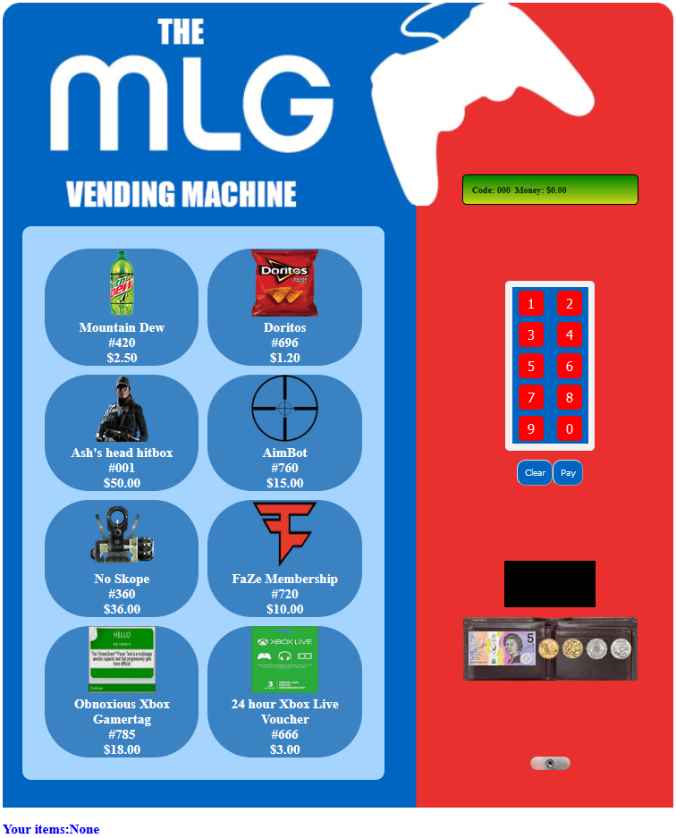Thank you for choosing the **MLG Vending Machine**. This user manual will provide an introduction to using the **MLG Vending Machine**, and also how to use the administration menu to restock the machine, return money, and give the user extra money. At MLG Services International, we pride ourselves in offering the best of the best products. In the rare event that you have any issues with the operation of this machine, please visit <https://github.com/N0bodyparticular/mlgVendingMachine/issues/new> to create an issue.

Figure : Main interface of the **MLG Vending Machine.**

# Section 1: Basic Operation

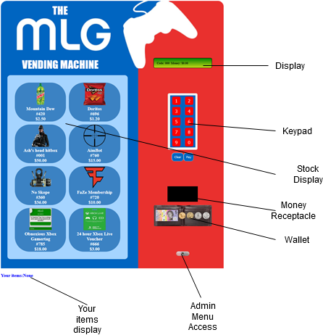The **MLG Vending Machine** has a comprehensible and fluid user interface. The diagram to the right outlines the basic functionality that the user has access to.

# Buying Items

The process for buying items is very straightforward:

1. Decide what item you want.
2. Enter the code using the keypad.
3. Drag enough money from the wallet into the receptacle.
4. Press pay.
5. You will now have bought the selected item. Press the clear button to return your change and clear the code.

Figure : Functionality of the **MLG Vending Machine.**

# Section 2: Administration Menu

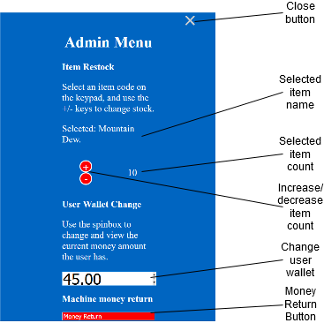In addition to the user interface for customers, the **MLG Vending Machine** also has a multipurpose administration menu for the system owner to perform maintenance.

## Accessing the Menu

Accessing the administration menu is very simple.

1. Click on the lock button to open the password entry.
2. Enter the password **“very strong password”** without quotes.

## Changing stock numbers

Once inside the menu you can change the amount of a product that is in the machine.

1. Type in the code for the item you wish to change in the keypad, e.g. 420 for Mountain Dew.
2. Use the + and – buttons to change the number of items.